## **Project “Yzerus” 1-Page GDD**

*Third person rpg where player must to save his continent . It will be connection between gothic 2 and diablo 3*

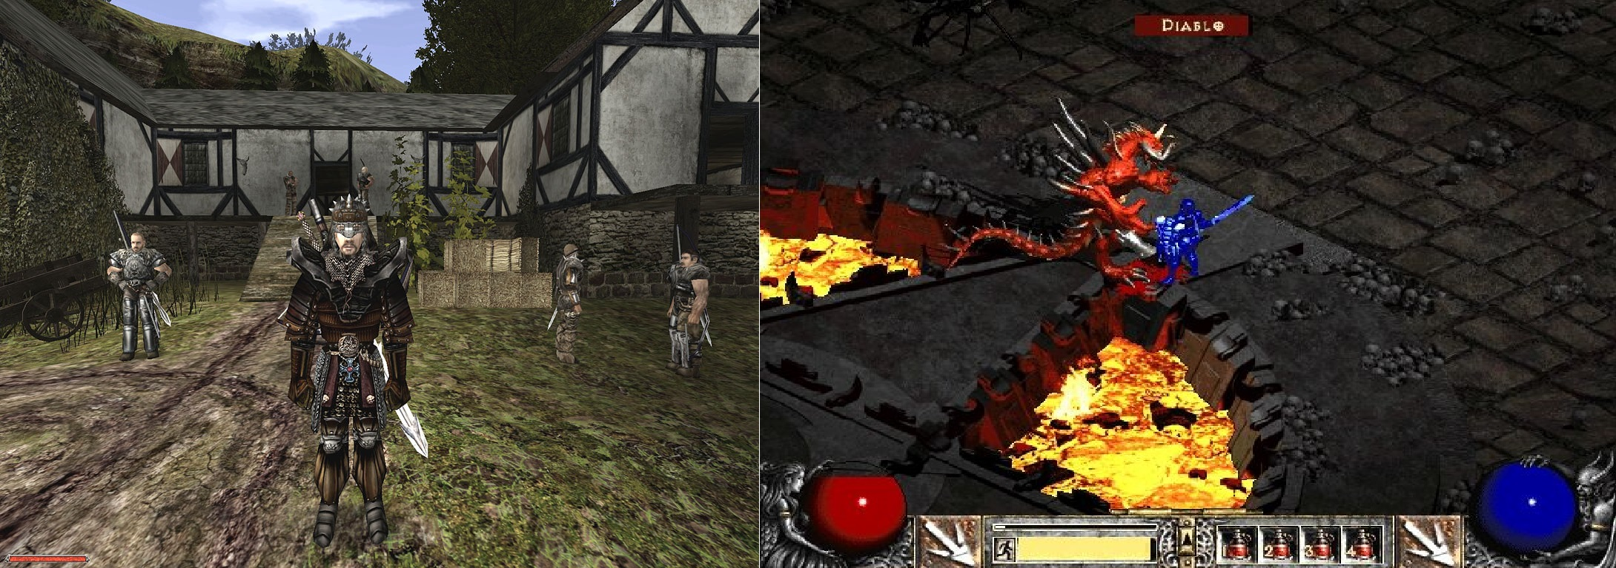

**Genre:** Fixed-camera , single player , 3rd-Person Action RPG  
**Target Audience:** 12+ fans of old rpg theme

**Controls:** Mouse + Keyboard (In fututre gampepad)

**Thematic Setting:** Fantasy + Medieval

**Tech Stack:** Unity + Blender + Gimp

**Platform(s):** Epic Games / PSN Store

**Game Moment:** Enemy are much stronger than you so you have to take a lot of expierence or find another way to defeat them. Effects like frozen or on fire can be both on player and enemy

**Game Summary:** Project „Yzerus” is going to be diablo camera style game with mosty gothic mechanism. Of course new mechanism will come such as movement and fighting. The game will take place in Anda contient in Thak town where player is going to die. Before death he is given a choice to go to Yzerus his family continent to kill king there whose betrayed other 4 continents. There will will be mostly dark theme with conspirancy.

**Core Player Experience:** 1)apathetic (at begining of game) ; 2)Awarenes ; 3)Uneasiness ; 4)Difficulty

**Central Theme:**

**Design Pillar:** Decision between fight or negotiate!

**Anticipated Remarkability:** That style of rpg was popular nowdays there are not so many of them

**Anticipated Steam Early Access Launch date:** Q2 2018

**Feature Development Priorities:**

**Comparative Products:**